Yo
generate a city landscape with Rembrandt style. The view is from inside a room looking through semi circular windows. Place XVIII century furniture. Decorate walls with Picasso and Dali paintings
Gemini
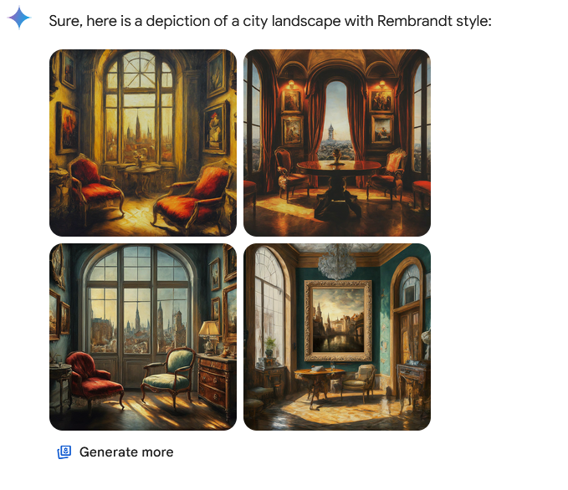
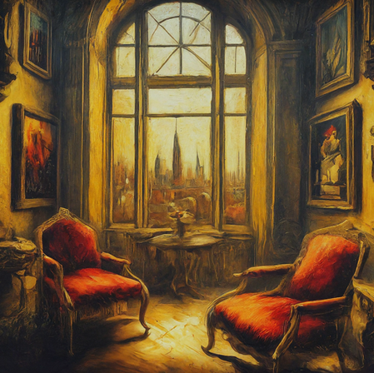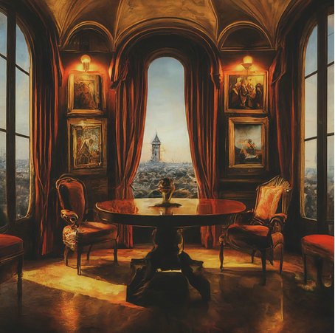
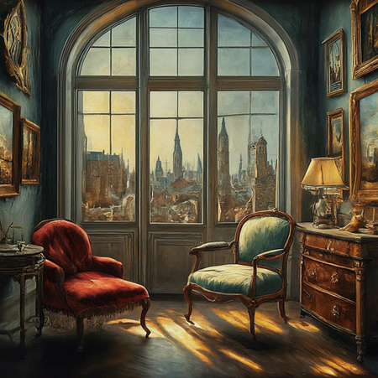
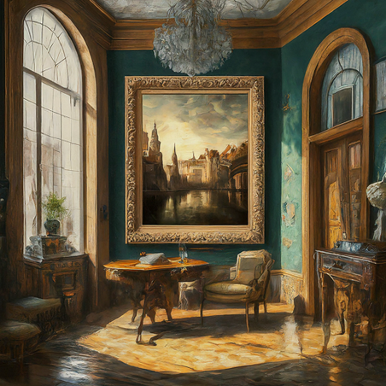

Award winning AI generated image:
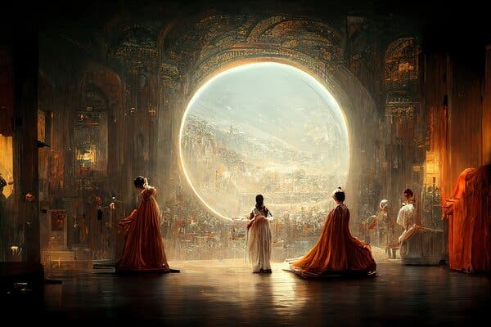

Yo
generate an image that explains long-tailed probability distributions

Gemini:
Sure, here is an image concept that explains long-tailed probability distributions:

Left side: A bell curve representing a normal distribution. Shade the area under the curve in a bright color to represent the high probability of events falling near the average.

Right side: A graph with a long tail extending to the right. The y-axis could represent frequency or probability, and the x-axis could represent a range of values for a specific variable (e.g., number of website visitors per day, amount of rainfall in a month, word frequency in a text). Shade the area under the curve towards the left side in a similar bright color as the normal distribution, but let the tail trail off into a dimmer color to depict the lower probability of extreme events.

Text overlay: Add text labels to the axis and a title such as "Normal Distribution vs. Long-Tailed Distribution". You could also include text boxes with examples of real-world phenomena that follow long-tailed distributions, such as:

Popularity of movies, books, or music
Stock market crashes
Number of followers on social media
Size of earthquakes

make the image
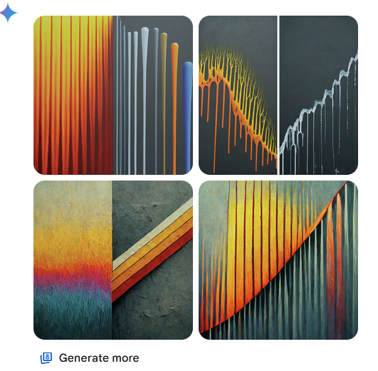

Yo
show an image that explains long-tailed probability distributions
Gemini:
